East Arm Project Report
Teleseismic component
3 November 2008

D B Snyder (GSC Ottawa)

Fieldwork Summer 2008

Ten teleseismic stations were installed 5–18 July in a linear array crossing Artillery Lake (Fig. 1). Four of the stations use satellite telemetry and Libra electronics (Fig. 2; L in Table 1) built by Nanometrics, Inc. of Kanata. ON and are 5-year-old stations rented from the POLARIS consortium of which NRCan is a member (www.polarisnet.ca). Six of the stations use flash memory data storage and Namometrics Taurus electronics (Fig. 3 T in Table 1); POLARIS built upgraded winterized components for these deployments. All four Libra stations continue to transmit data to the data archiving facility in Ottawa at present. The memory chips in the six Taurus stations were exchanged in mid-September and their data quality is currently being analyzed.

The station components were assembled at the Yellowknife Geophysical Observatory in late June. Some were transported by barge to Ft. Resolute in early July; the remainder were flown to Lutsel K’e by aircraft on 6 July. Single and Twin Otter float planes were then used to transfer each station to an appropriate position on the array. An EC120 helicopter was then used to transport delicate electronics, tools and installation crews to each site from the field base at Trophy Lodge, Ft. Reliance. The installation party included: David Snyder (GSC, lead seismologist), Brian Roberts (GSC, Taurus technologist), Issam Al-Khoubbi (POLARIS Libra technologist), Tsatsiye Catholique (summer intern from Lutsel K’e), Fred Marlowe (labourer & wildlife protection). One field party installed a Libra station in two days. The second party organized transport of gear and installation of Taurus stations. Actual time building the array was 10 days and all stations were actively recording earthquakes on 16 July.

To date, earthquake record quality is good (Fig. 4) and comparable to previous POLARIS station installations from Lac de Gras to Kennady Lake (station KNDN on Fig. 1). As of mid-September, 26 earthquakes suitable for the analysis planned have been recorded (Table 2). Twelve of these can be used for SKS-anisotropy studies that reveal structural fabrics within the mantle that can sometimes indicate presence of kimberlite dyke swarms (Fig. 5). Seventeen earthquakes are suitable for discontinuity studies that can detect large-scale layering within the mantle and thus regions where ancient carbon was subducted from the surface to depths where diamonds can form.

Table 1. Station locations

Station | Latitude | Longitude | elevation | Location | distance | type
COKN | 63.27018 N | 108.76241 W | 366 m | N Cook Lake | 27.5 KNDN | L
WLMN | 63.23652 N | 108.48018 W | 405 |  | 14.8 | T
ARTN | 63.08432 N | 108.24690 W | 395 | 5 km NW of Artillery L. | 20.6 | T
FABN | 62.93693 N | 107.93379 W | 418 | W of Fabian Lake | 22.5 | T
SNLN | 62.83043 N | 107.61020 W | 364 | W Sandy Lake | 20.8 | L
EA06 | 62.7490 N | 107.35362 W | 415 |  | 16 | T
WHFN | 62.55914 N | 107.08658 W | 365 | SW Whitefish Lake | 25 | L
TMBN | 62.29986 N | 106.68648 W | 380 | SW Timberhill Lake | 35 | T
HOWN | 62.23865 N | 106.18101 W | 359 | W Howard Lake | 27 | T
GDLN | 62.01994 N | 105.99444 W | 389 | N Gardenia Lake | 26.2 | L

Table 2. Earthquakes recorded

East Arm | date | (Julian) | time | SKS? | quality
Greece | 15-Jul-08 | 197 | 3:26:37 |  | 1
Honshu | 19-Jul-08 | 201 | 2:39:30 |  | 2
Santa Cruz Island | 19-Jul-08 | 201 | 9:27:06 | Y
Fiji | 19-Jul-08 | 201 | 22:39:54 | Y
Honshu | 21-Jul-08 | 203 | 11:30:32 |  | 2
Sichuan-Gansu | 01-Aug-08 | 214 | 8:32:44 |  | 1
Kuril | 04-Aug-08 | 217 | 4:42:14 |  | 2
Banda Sea | 04-Aug-08 | 217 | 20:45:12 | Y
Sichuan-Gansu | 05-Aug-08 | 218 | 9:49:18 |  | 1
Andreanof Is. | 07-Aug-08 | 220 | 18:30:03 |  | 3
Sumatra | 08-Aug-08 | 221 | 6:37:44 | Y
Andaman Is. | 10-Aug-08 | 223 | 8:20:32 | Y
W Xizang | 25-Aug-08 | 238 | 13:21:59 | Y | 1
N. Peru | 26-Aug-08 | 239 | 21:00:37 |  | 1
Lake Baikal | 27-Aug-08 | 240 | 1:35:31 |  | 2
Iran-Iraq | 27-Aug-08 | 240 | 21:52:39 |  | 3
Papua N G | 30-Aug-08 | 243 | 15:22:25 | Y
Sant d Est., Argentina | 03-Sep-08 | 247 | 11:25:13 | Y | 3
Vanuatu | 08-Sep-08 | 252 | 3:03:22 | Y
Vanuatu | 08-Sep-08 | 252 | 18:52:08 | Y | 4
S. Iran | 10-Sep-08 | 254 | 11:00:41 | Y | 1
Mid-Atlantic | 10-Sep-08 | 254 | 13:08:15 |  | 2
Halmahera | 11-Sep-08 | 255 | 0:00:02 | Y
Hokkado | 11-Sep-08 | 255 | 0:20:53 |  | 2
Komandorsky | 12-Sep-08 | 256 | 23:07:50 |  | 3
Columbia | 13-Sep-08 | 257 | 9:32:00 |  | 1

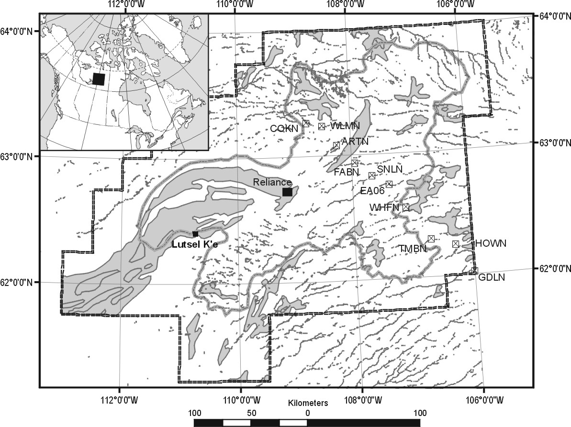

Figure 1. Location map showing station locations and Ft. Reliance.

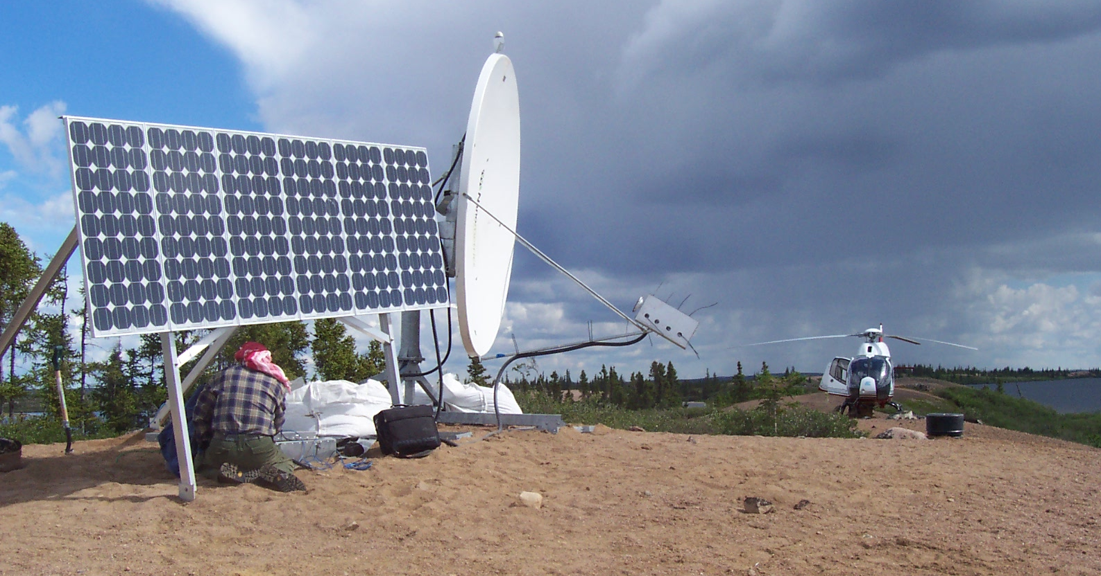

Figure 2. Libra station GDLN at Gardenia Lake receiving final installation check by I. Al-Khoubbi. Black plastic cap in front of the helicopter is the seismometer vault dug < 1 meter into the sand. Satellite dish is 2.4 m in diameter with GPS antennae at its top.

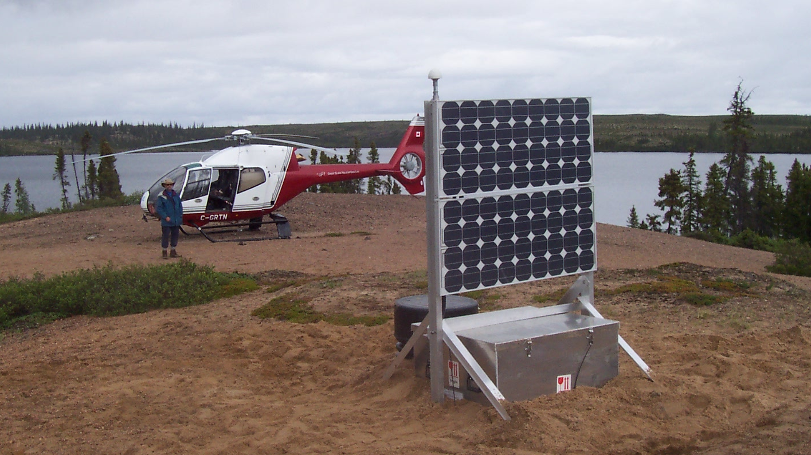

Figure 3. Taurus station TMBN at Timberhill Lake after completion of installation by D. Snyder & B. Roberts.

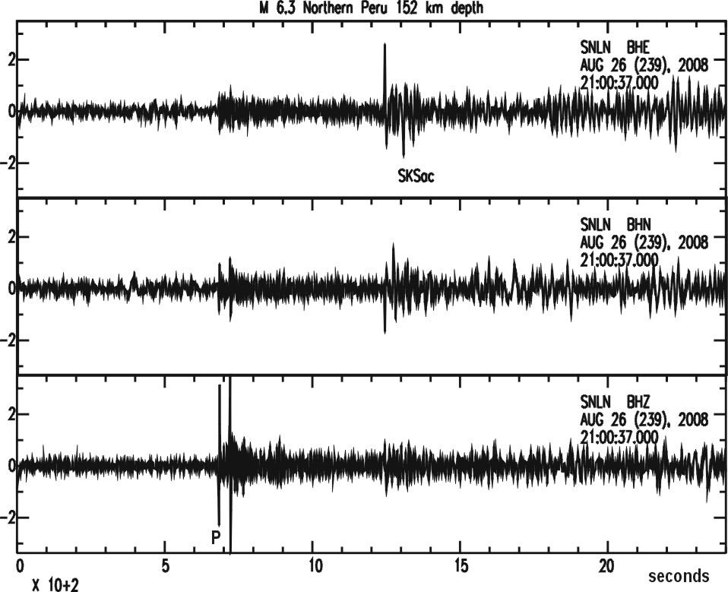

Figure 4. Example of earthquake record, here as observed at station SNLN on 26 August from an earthquake that occurred 75° away in northern Peru. Clear primary (P) and secondary (SKS) waves are observed at 680 and 1230 seconds travel time, respectively.

