A New Circa-2000 Land Cover map of Northern Canada at 30-m Landsat Resolution

I. Olthof, R. Latifovic and D. Pouliot

Abstract. Previous northern land cover of Canada mapped within national or circumpolar products are too coarse thematically or spatially to address all emerging northern issues, including land use, wildlife and climate change. This paper presents the first 30m resolution land cover map of northern Canada designed to help managers and policymakers address these issues. Orthorectified circa-2000 Landsat data from CTI Geogratis were acquired for Northern Canada from the treeline to the northern tip of Ellesmere Island and were combined into several radiometrically-balanced large-area mosaics. Literature on northern land cover and vegetation mapping as well as numerous northern vegetation surveys were examined to determine an optimal set of land cover classes to map and provide some reference information to assist class labelling. Field data gathered during numerous northern campaigns over the past few years were combined with land cover information from maps of protected areas generated by other government agencies such as Parks Canada, the Geological Survey of Canada and Territorial Governments to form a reference dataset for training and validation. The map will be made publicly available for download through Natural Resource Canada’s Geogratis portal in 1:250k National Topographic System (NTS) mapsheets.

Introduction

Land cover is a fundamental land surface parameter that is most often derived from remotely sensed imagery. In Canada, numerous national land cover products have been generated from coarse-resolution (1-km) imagery from the AVHRR and SPOT VEGETATION (VGT) sensors. Easy access to Canada’s southern landmass, a history of resource extraction and experience interpreting satellite imagery have all contributed to accurate and detailed land cover in southern Canada’s developed agriculture and forested regions. However, the absence of such factors in northern Canada has led to overly generalized northern land cover in previous national products.

Vegetation maps focussed on northern Canada (Gould et al., 2002) and the circumpolar north (Walker et al., 2002) have been generated in recent years that combine remotely-sensed image interpretation with expert knowledge of the environmental controls on arctic plant distributions in a GIS environment. These maps contain thematic detail not present in national-level land cover products, but provide no greater spatial detail because they are based on 1-km AVHRR imagery and ancillary data at a coarse 1:7.5 M-scale. These maps are well-suited to the purposes they were intended for, including numerous international efforts related to global environmental change and education. However, certain applications require more detail than these maps can provide, such as wildlife conservation, resource development and carbon accounting for climate change studies involving land use and land use change.
Canada Centre for Remote Sensing, 588 Booth Street Ottawa, ON, K1A 0Y7
iolthof@ccrs.nrcan.gc.ca, (613) 947-1233.

Detailed maps of certain regions in northern Canada have been produced, including several northern Parks and protected areas. The knowledge that is imbedded in these maps may be useful for extending land cover beyond previously mapped regions to the whole of northern Canada. However, since none rely on a common land cover legend, differences among class definitions can lead to incompatible or inconsistent interpretation when two or more land cover maps are extended over the same region. Thus, differences need to be reconciled by defining a land cover type that includes common features of both classes being mapped, or one of the mapped classes should be considered in error.

In this paper, we use normalized 30m Landsat data from year circa-2000, existing land cover products over of protected areas, site-level field data, ancillary GIS data, literature on northern vegetation and northern mapping and high resolution images from the Ikonos satellite to interpret and map northern land cover of Canada at 30m resolution. This product will provide the first thematic and spatially detailed coverage of northern Canada that uses a common legend and is consistent in all regions. Thus, all northern parks and protected areas now have access to land cover information that allows managers to view each area separately, or for the first time, different regions together in a comparable fashion. Consistent radiometry on which the map is based as well as a consistent legend now allow areas to be compared or combined as needed.

Satellite data

Landsat data were processed by two groups and three different methods to form the full coverage north of the treeline, as defined by Timoney et al., 1992. A Baffin Island mosaic was created using the method by Gibson and Nedelcu (2008), which uses multiple overlapping paths, a sensor and satellite orbit model and few ground control points required to generate georeferenced image products that are subsequently orthorectified. By combining multiple paths of data and resampling once, clear-sky swaths are obtained and original radiometry is preserved.

In addition, freely available orthorectified Landsat data covering Canada north of the treeline were downloaded from the Centre for Topographic Information (CTI) through the Geogratis portal, and the University of Maryland through the Global Land Cover Facility (GLCF) portal. Data were reprojected to the spatial reference and radiometrically balanced using year-2000 SPOT VGT data (Latifovic et al., 2004) following the procedure in Olthof et al. (2005). Other large-area Landsat mosaics of northern islands, including Southampton and islands in the Sverdrup basin, were generated using overlapping areas between scenes and automated image matching procedures. Landsat mosaics north of the coverage of VGT (72.25 degrees N) were normalized using successive overlap areas with Landsat data located to the south to produce consistent radiometry for the full coverage, which can be seen in a 250m resampled version in Figure 1.

Sixteen individual radiometrically balanced 30m resolution large-area mosaics were created of Landsat bands 3 (Red), 4 (Near Infrared; NIR) and 5 (Shortwave Infrared; SWIR). Each mosaic was enhanced using a common lookup table following the Enhancement Classification Method (ECM; Beaubien et al., 1999) in order to compress the dynamic ranges of water and clouds, snow and ice on the low and high end of the dynamic ranges, respectively, while stretching the range representing land cover to enhance the visual separability among classes. Enhanced images were clustered to 200 spectral clusters using the Fuzzy K-means algorithm (Bezdek, 1973) and a pseudo-colour table representing cluster means in NIR, SWIR and Red displayed as Red, Green and Blue (RGB) was applied.

Ancillary data

Ancillary data were downloaded from the Alaska Geobotany Center’s Circumpolar Arctic Vegetation Map (CAVM) data page, including the treeline (Timoney et al., 1992) and bioclimatic zones, which represent biotic criteria that subdivide the arctic into units reflecting climatic gradients (Edlund and Alt, 1989). Additional 1:50k data on water bodies and elevation were downloaded from the Centre for Topographic Information’s (CTI) National Topographic Data Base (NTDB) through the Geogratis web portal. The Geological map of Canada (Wheeler et al., 1997) was used to stratify based on parent material. A map was generated that combined bioclimatic zone, parent material and elevation into eight different strata that were mapped separately. These strata were the same as those used by other groups to map northern Canada and the circumpolar north (Gould et al., 2002; Walker et al., 2002), as they have been determined to control northern vegetation distributions at a global scale. Bioclimatic zones three to five were mapped together due to a lack of reference data for bioclimatic zones 1 and 2.

Classification

Each of the sixteen large-area cluster images were mosaiced into a 250m coverage of the whole Canadian Arctic using Nearest Neighbour sampling. Ancillary data were also gridded into the same coverage. This enabled the creation of an overview product that could be treated synoptically, instead of examining each large-area mosaic separately one at a time. Classification and extensive visual quality checking was performed on the resampled data before generating the full resolution product on the sixteen mosaics (Figure 1).

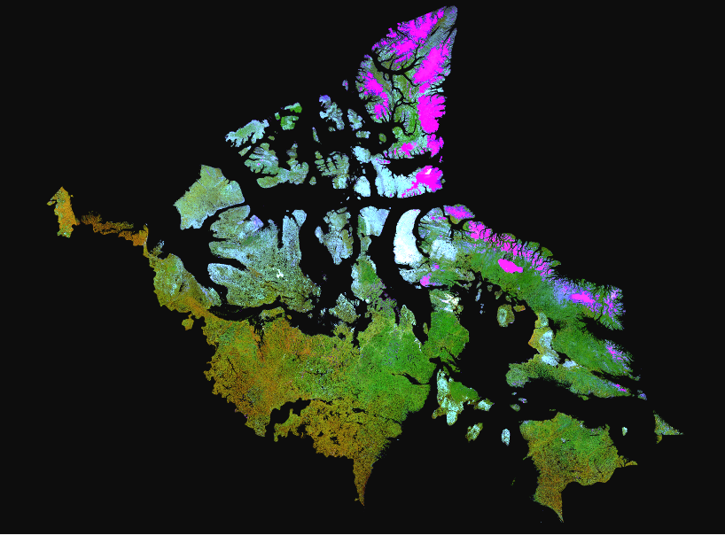

Figure 1. Landsat data for the Canadian Arctic north of the treeline, bands 4, 5, 3 displayed as R, G, B.

A new, northern land cover legend was generated by examining 13 northern vegetation legends and extracting common or compatible classes among them. Four digital land cover maps were obtained for protected areas in northern Canada, two of which were within bioclimate zone 5, and one in each of zone 3 and 4 (Figure 2). A lookup table was generated to transform existing land cover products to the common legend (Table 1). Separate lookup tables were then generated that related the 200 spectral clusters from the normalized Landsat

mosaic to classes from the common legend for each of the four land cover products using a majority rule. A side-by-side examination of lookup tables allowed the interpreter to check spectral clusters that have been mapped to separate classes in each of the classifications. In addition to the 250m resampled coverage used for quality checking, over each of the four existing protected area classifications as well as three additional regions where field data had been collected (Iqaluit, Nunavut; Lupin, NWT; Tuktoyaktuk, NWT), classifications were generated at full 30m resolution for visual assessment and quality control.

Because the four land cover classifications used to guide the labelling of our product cover different bioclimatic zones and different regions, spectral clusters should not necessarily represent the same land cover class in each zone. This is also true where ambiguity exists in class definition or where different interpreters view the land cover differently. For clusters that span two or more zones, these differences need to be reconciled so that they represent the same class at the boundary between two zones. Failure to do this produces a discontinuous land cover product between zones, such that zones are visible through the class distribution in the final product.

To reconcile differences and similarities between zones, each zone was buffered and the clusters that occurred frequently on each side of a zone boundary were examined to ensure that they mapped to the same class. Generally, a voting rule was used where disagreement existed among classes assigned to spectral clusters in different lookup tables. Experience interpreting land cover and available reference data were also key in making decisions about cluster labelling (Figure 2). Those clusters that occurred in adjacent zones but were not frequent along the boundary were allowed to map to separate classes.

Figure 2. Location of reference data used to assist in cluster labelling.

Table 1. Association among classes in the digital land cover maps of protected areas shown in Figure 2, and the common legend used to map northern land cover.
Common legend |  | Delta, GSC |  | Yukon Coastal Plain, EC |  |  |  | Aulavik NP |  |  |  | Tuktut NP
 |  | Zone 5 |  | Zone 5 |  |  |  | Zone 3 |  |  |  | Zone 4
Graminoid
1 | tussock graminoid tundra (< 25% dwarf shrub) |  |  | 10. moist cottongrass tussock |  |  |  | 11. Hummock Tundra |  |  |  | 2. tussock tundra
2 | wet sedge | 7. Grass / Sedge |  | 5. wet graminoid or wet bryophyte | 6. wet graminoid, low shrub |  | 8. moist tundra with wet inclusions | 2. Depression Wet Sedge Meadow |  | 6. Slope Wet Sedge Meadow |  | 1. wet sedge meadow
3 | moist to dry non-tussock graminoid / dwarf shrub tundra (50-70% cover) | 2. Dry Tundra (willow-heath) willow/sedge |  | 9. moist graminoid (non-tussock) |  |  |  | 7. Sedge Dominated Dry Tundra | 8. Mesic Meadow 50% |  | 9. Mesic Meadow 70% | 3. mesic tundra
4 | dry graminoid prostrate dwarf shrub tundra (70-100% cover) | 1. Dry Tundra (sedge-heath) |  |  |  |  |  | 10. Grass Dominated Dry Tundra |  |  |  | 5. dry tundra
Shrub
5 | low shrub (< 40cm; > 25% cover) |  |  | 11. low shrub tundra |  |  |  |  |  |  |  | 4. shrub tundra
6 | tall shrub (> 40cm; > 25% cover) | 12. Tall Willow & Alder (dense cover) |  | 12. shrub thicket
7 | prostrate dwarf shrub |  |  | 13. dry dryas tundra |  |  |  | 4. Successonal Dry Tundra
Sparse vegetation
8 | sparsely vegetated bedrock (2-10% cover)
9 | sparsely vegetated till-colluvium (2-10% cover) |  |  | 14. dry partially vegetated or barren |  |  |  | 5. Stoney Sandy Barren |  |  |  | 7. rocky barrens
10 | bare soil with cryptogam crust - frost boils |  |  |  |  |  |  |  |  |  |  | 6. sparsely vegetated ground
Wetlands
11 | wetlands | 3. Wetlands | 6. Intertidal | 4. aquatic tundra
12 | barren | 11. Beach / Bare Soil |  | 7. wet barrens |  |  |  | 1. Bare Ground |  |  |  | 9. sand and gravel
13 | ice / snow |  |  | 1. ice |  |  |  | 13. Snow and Ice |  |  |  | 11. snow and ice
14 | shadow | 5. Cloud |  | 15. mountain or cloud shadows |  |  |  | 12. Clouds and Shadows |  |  |  | 13. cloud and shadow
15 | water | 10. Clear Water | 8. Turbid Water | 2. clear water |  | 3. silty water |  | 3. Water |  |  |  | 10. water

The Classification by Progressive Generalization (CPG) (Cihlar et al., 1998) approach was used in a last step with the pre-determined lookup tables used as a guide for final cluster merging and labelling. The CPG method is then used to merge clusters based on spectral similarity and spatial proximity to generalize in a series of steps from the 200 cluster image to the final classification product. Visual quality checks are key at each generalization step, and are performed by applying a pseudo-colour table generated from the enhanced spectral bands and comparing the resulting image to the previous generalization step to ensure no loss of relevant land cover information. The overall goal is to preserve shapes and features in the land cover classification that are present in the original imagery. Lookup tables were checked to ensure that the semi-automated cluster merging as suggested by examining multiple existing land cover products did not violate the principles of the CPG method.

Once lookup tables were finalized and checked on the 250m resampled product, they were applied to each of the sixteen 30m large area mosaics under the appropriate stratum based on geology, bioclimatic zone and elevation. NTDB water bodies were gridded and buffered to one pixel, and clusters representing water beneath this water mask were assigned to the water class. Topographic shadow was classified by assigning dark spectral clusters not beneath the water mask to shadow in areas of high relief based on the DEM. Three hundred and eighty 1:250k NTDB mapsheets representing Canada north of the treeline were cut from the sixteen large area classifications. A final quality check and manual editing was performed on these sheets to remove sea and lake ice and fill in water in no data areas representing open water (Figure 3).

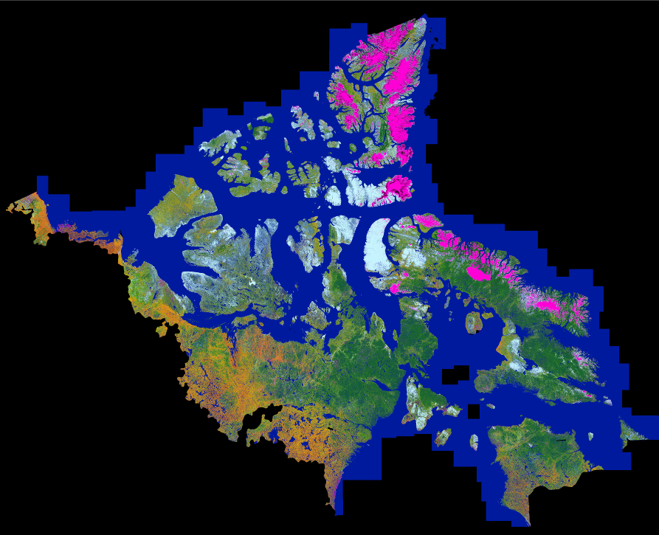

Figure 3. Three hundred and eighty 1:250k NTDB land cover tiles mosaiced at 250m spatial resolution forming the land cover of Canada north of the treeline.
Validation

To date, minimal validation has been performed on the final product considering its vast coverage. For three areas where field data were collected, per pixel accuracy assessments were performed (Table 2). Additional reference data has is being continuously added to the reference database shown in Figure 2, which should provide sufficient data to do a proper validation in the future. In addition to a limited per pixel accuracy assessment, agreement between the final product and CAVM was assessed by examining the resampled 250m land cover distribution within each CAVM class. CAVM can be considered as a standard on the circumpolar artic vegetation distribution at a broad scale due to the rich information imbedded in this map stemming from extensive northern experience of the primary investigators. However, CAVM classes represent plant communities, while Landsat classes tend more towards growth form and less towards communities. Thus, CAVM lacks the finer scale detail present in the current map. Nonetheless, a comparison between these maps is informative to see if the broad scale variation in CAVM is present in our Landsat classification.

Table 2. Per pixel overall accuracy for a limited field samples collected in Bioclimatic zones 4 and 5.
Region | Bioclimatic zone | N | Overall accuracy
Iqaluit, Nunavut | 4 | 46 | 84.7%
Lupin, NWT | 5 | 23 | 78.3%
Tuktoyaktuk, NWT | 5 | 7 | 71.4%

A matrix showing the Landsat land cover distribution beneath each of the CAVM vegetation community classes is presented in Table 3. Only Landsat classes contributing ten percent or more to the CAVM class are shown for clarity. Careful examination of this matrix reveals a high level of agreement between these maps. For example, the CAVM low-shrub tundra class is composed of 23% tussock graminoid tundra (with less than 25% dwarf shrub), 23% low shrub (less than 40cm tall), and 9% tall shrub (more than 40cm tall), in total accounting for 74% of the CAVM class. A breakdown of all CAVM classes is beyond this discussion, but all CAVM classes can be understood in terms of their composition as determined by Landsat.

Table 3. Distribution of Landsat land cover within each Circumpolar Arctic Vegetation Map (CAVM) class.
Landsat class | 1 | 2 | 3 | 4 | 5 | 6 | 7 | 8 | 9 | 10 | 11 | 12 | 13 | 14 | 15
CAVM class | tussock graminoid tundra (< 25% dwarf shrub) | wet sedge | moist to dry non-tussock graminoid / dwarf shrub tundra | dry graminoid prostrate dwarf shrub tundra | low shrub (< 40cm; > 25% cover) | tall shrub (> 40cm; > 25% cover) | prostrate dwarf shrub | sparsely vegetated bedrock (2-10% cover) | sparsely vegetated till-colluvium (2-10% cover) | bare soil with cryptogam crust - frost boils | wetlands | barren | ice / snow | shadow | water | Total %
Cryptogam, herb barren |  |  |  |  |  |  |  |  | 22 |  |  | 45 |  |  |  | 67
Rush/grass, forb, cryptogam tundra |  |  |  |  |  |  |  | 14 | 19 | 14 |  | 12 |  |  |  | 59
Cryptogam barren complex (bedrock) |  |  |  |  |  |  | 10 | 53 |  |  |  |  |  |  | 11 | 74
Prostrate dwarf-shrub, herb tundra |  |  |  |  |  |  |  |  | 20 | 15 |  | 19 |  |  | 10 | 63
Graminoid, prostrate dwarf-shrub, forb tundra | 11 | 12 |  |  |  |  | 11 |  |  | 17 |  |  |  |  | 10 | 62
Prostrate/Hemiprostrate dwarf-shrub tundra |  |  |  |  |  |  | 10 | 46 |  |  |  |  |  |  | 10 | 66
Nontussock sedge, dwarf-shrub, moss tundra | 10 | 10 |  |  | 10 |  | 13 | 13 |  |  |  |  |  |  | 13 | 68
Tussock-sedge, dwarf-shrub, moss tundra | 20 |  |  |  | 14 |  | 17 |  |  |  |  |  |  |  | 13 | 64
Erect dwarf-shrub tundra | 13 |  |  |  |  |  | 19 | 13 |  |  |  |  |  |  | 17 | 62
Low-shrub tundra | 23 |  |  |  | 23 | 9 |  |  |  |  |  |  |  |  | 18 | 74
Sedge/grass, moss wetland | 10 | 13 |  |  |  |  | 11 |  | 10 | 14 |  |  |  |  | 14 | 71
Sedge, moss, dwarf-shrub wetland |  | 24 | 10 |  |  |  |  |  |  |  |  |  |  |  | 13 | 47
Sedge, moss, low-shrub wetland | 11 |  |  |  | 11 |  | 12 |  |  |  | 12 |  |  |  | 24 | 71
Noncarbonate mountain complex |  |  |  |  |  |  |  | 26 | 14 |  |  | 15 |  |  |  | 55
Carbonate mountain complex |  |  |  |  |  |  |  |  | 22 |  |  | 20 |  | 13 |  | 55
Nunatak complex |  |  |  |  |  |  |  |  |  |  |  | 22 | 44 | 11 |  | 76
Glaciers |  |  |  |  |  |  |  |  |  |  |  |  | 75 | 10 |  | 85
Water |  |  |  |  |  |  |  |  |  |  |  |  |  |  | 87 | 87
Lagoon |  |  |  |  |  |  |  |  | 8 |  |  |  |  |  | 72 | 80

Acknowledgements

We would like to acknowledge Robert McGregor and Stefan Nedelcu for their contributions in processing Landsat data for several islands in the high Arctic under the Secure Canadian Energy Supply Program, Hydrocarbon Potential of the Arctic Project. We also gratefully acknowledge Dr. Frank Ahern for his comments.

References

Beaubien, J., Cihlar, J., Simard, G. and Latifovic, R., 1999. Land cover from multiple Thematic Mapper scenes using a new enhancement-classification methodology. Journal of Geophysical Research, 104: 27909-27920.

Bezdek, J.C., 1973. Fuzzy mathematics in pattern classification. Ph.D. dissertation, Cornell University, Ithaca, NY.

Cihlar, J., Xiao, Q., Chen, J., Beaubien, J., Fung, K., and Latifovic, R., 1998. Classification by progressive generalization: a new automated methodology for remote sensing multi channel data. International Journal of Remote Sensing, 19: 2685-2704.
Edlund, S. and Alt, B.A. 1989. Regional congruence of vegetation and summer climate patterns in the Queen Elizabeth Islands, Northwest Territories, Canada. Arctic, 42: 3-23.
Gibson, J.R. and Nedelcu, S., 2008. An improved approach for the production of satellite-based geospatial reference imagery. International Journal of Digital Earth, 1: 221-239.

Gould, W.A., Edlund, S., Zoltai, S., Raymolds, M., Walker, D.A. and Maier, H., 2002. Canadian arctic vegetation mapping. International Journal of Remote Sensing, 23: 4597-4609.

Latifovic, R., Zhi-Liang, Z., Cihlar, J., Giri, C., and Olthof, I., 2004. Land cover mapping of North and Central America – Global Land Cover 2000. Remote Sensing of Environment, 89: 116-127.

Olthof, I., Pouliot, D., Fernandes, R., and Latifovic, R., 2005. Landsat ETM+ radiometric normalization comparison for northern mapping applications. Remote Sensing of Environment, 95: 388-398.

Timoney, K.P., La Rii, G.H., Zoltai, S.C., and Robinson, A.G., 1992. The high subarctic forest-tundra of Northwestern Canada: position, width, and vegetation gradients in relation to climate. Arctic, 45:1-9.

Walker, D.A., Gould, W.A. and Raynolds, M.K., 2002. The circumpolar Arctic vegetation map: Environmental controls, AVHRR-derived base maps, and integrated mapping procedures. International Journal of Remote Sensing, 23: 2551-2570.

Wheeler, J.O., Hoffman, P.F., Card, K.D., Davidson, A., Sanford, B.V., Okulitch, A.V., and Roest, W.R., 1997: Geological Map of Canada, Geological Survey of Canada, Map D1860A.

